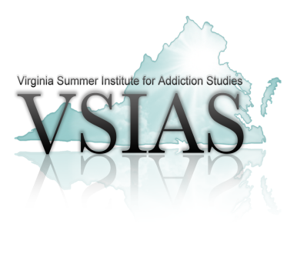
Ron Pritchard Visionary Leadership Award
Nomination Form

The Ron Pritchard Visionary Leadership Award (RPVLA) is awarded each year to an individual who has demonstrated extraordinary leadership and contribution to the substance abuse prevention, treatment and recovery field. **VSIAS Faculty selects the most warranted candidate based on the nominees submitted for review. The individual selected to receive the RPVLA will be notified and invited to the Annual VSIAS Conference as a guest of VSIAS. The selected candidate will be honored during a special luncheon at the VSIAS Conference July 21-24, 2024, held at the Woodlands Conference Center in Williamsburg, VA .

Please answer the following questions as thoroughly as possible. In addition, please submit at least one letter of support and recommendation from an individual practicing in the substance abuse field.
The application and support letter(s) must be submitted to Melanie Meadows at melanie.y.meadows@gmail.com no later than April 19, 2024.

Nominator’s Name/Agency: ___________________________________________________________

- Nominee’s Name:
Title:
Organization:
Address:
Phone #:

- Nominee’s Achievements and Demonstration of Leadership:

- Nominee’s Length of Service to the field of substance abuse and addiction:

- How has the nominee’s achievements added value to the field of substance abuse, specifically addiction prevention, treatment and recovery?

