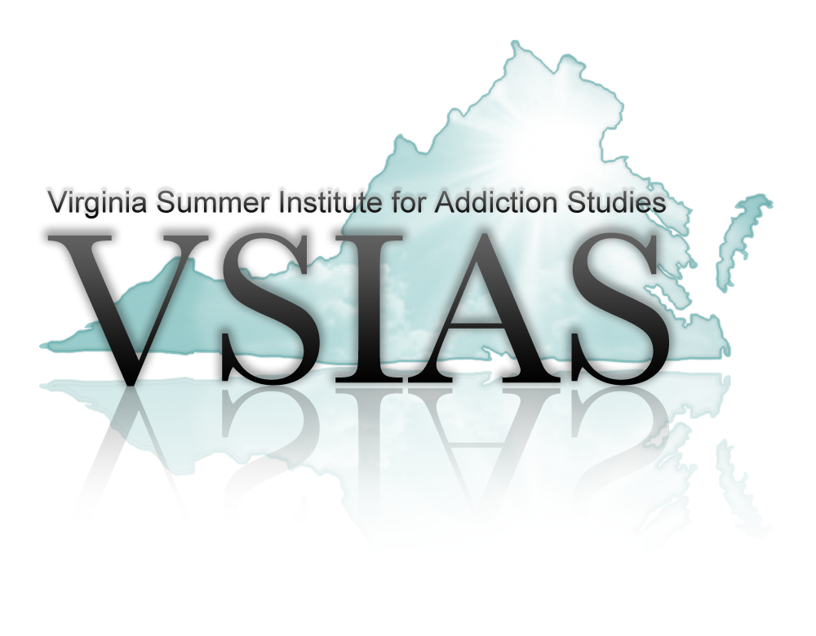

Dear Supporters,

The Virginia Summer Institute for Addiction Studies (VSIAS) would like to extend an invitation to exhibit at its 24th year in Historic Williamsburg, Virginia, July 20 – 23, 2025.

The Institute provides an excellent marketing opportunity in the setting of Historic Williamsburg, Virginia. The Institute will be at Williamsburg Lodge, 310 S. England St, Williamsburg, VA 23185, one of the deluxe Colonial Williamsburg properties. This means added convenience for you and our participants. Comfortable guest rooms, adjacent meeting space, complimentary parking, accessible internet, restaurant for dining in the hotel, additional restaurants and attractions nearby, make the Williamsburg Lodge an outstanding location for the 24th year of the Virginia Summer Institute.

This Institute is designed for professionals in the field of substance use disorders and mental health, who are interested in keeping current on the latest techniques and resources available. Participants come from across the state to attend this conference. This year’s theme is “Pathways to Progress, Recovery Across the Continuum”.

We hope that you will join us this year! We value your support and strive to make this a successful event for each supporter. All breaks are set up near the exhibits to enhance engagement. There will be time set aside to acknowledge supporters and allow time for door prizes.

Exhibit set-up begins Sunday, July 20th, at 3 pm.
Exhibit must be clear and broken down no later than 6:00 pm, Wednesday, July 23rd.

“The exhibitor assumes the entire responsibility and liability for losses, damages, and claims arising out of exhibitor activities on the Hotel premises and will indemnify, defend, and hold harmless the Hotel, its owner, and its management company, as well as their respective agents, servants, and employees from any and all such losses, damages, and claims.”

Hotel will not be responsible or liable for any loss, damage, or claims arising out of exhibitor activities on the Hotel’s premises except for any claims, loss, or damages arising directly from the Hotel’s own negligence.

Visit the Virginia Summer Institute for Addiction Studies website at www.vsias.org for registration details. We sold out last year and had a waiting list. We cannot guarantee a table for you if you do not register by June 3, 2025. You will receive confirmation once you register. Please bring this with you to the conference.

For questions regarding exhibits/supporters, contact Cindy Blanton at 540-446-3929 or email cblanton@natcaptreatment.org. Any questions regarding registration, please contact
Alicia Hurdle at info@vsias.org or call

We look forward to your sponsorship and exciting opportunity to share your program and services with other professionals throughout the Commonwealth of Virginia.

Cindy Blanton, CSAC, NCACI
VSIAS Conference Faculty

