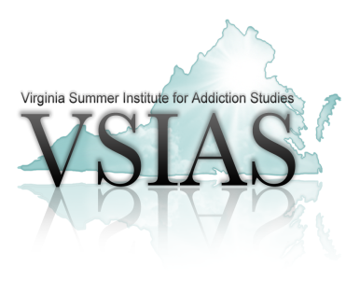**Ron Pritchard Visionary Leadership Award**

***Nomination Form***

The Ron Pritchard Visionary Leadership Award (RPVLA) is awarded each year to an individual who has demonstrated extraordinary leadership and contribution to the substance use prevention, treatment and recovery field. **VSIAS Faculty selects the most warranted candidate based on the nominees submitted for review. The individual selected to receive the RPVLA will be notified and invited to the Annual VSIAS luncheon as a guest of VSIAS. The selected candidate will be honored during the special luncheon at the VSIAS Conference Tuesday, July 22, 2025, held at the Williamsburg Lodge Conference Center in Williamsburg, VA.

Please answer the following questions as thoroughly as possible. In addition, please submit at least one letter of support and recommendation from an individual practicing in the substance use disorder field.

**The application and support letter(s) must be submitted to Cindy Blanton at** [cblanton@natcaptreatment.org](mailto:cblanton@natcaptreatment.org) **no later than May 1, 2025.**

**Nominator’s Name/Agency:**

1. **Nominee’s Name:**

**Title:**

**Organization:**

**Address:**

**Phone #:**

**Email:**

1. **Nominee’s Achievements and Demonstration of Leadership:**
2. **Nominee’s Length of Service to the field of substance use and addiction:**
3. **How have the nominee’s achievements added value to the field of substance use, specifically addiction prevention, treatment and recovery?**